Adobe stopped supporting Flash Player beginning December 31, 2020 (“EOL Date”)
FAA has contracted with HARMAN to extend Flash Player on FAA machines temporarily. Courses that still contain Flash will run on FAA computers if they have the Adobe Flash Player by HARMAN installed.
Click the link below for a list of courses contained Adobe Flash. If you’re having trouble with these courses (and you’re using IE on an FAA machine), please confirm that you have Adobe Flash Player by HARMAN International on your computer by checking your Programs and Features:
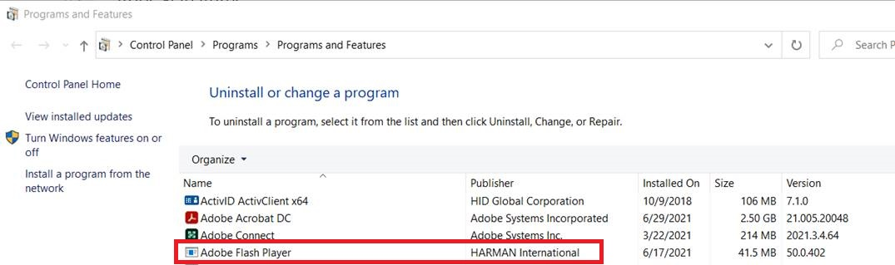
If you do have Adobe Flash Player by HARMAN, try clearing your cache to see if that helps.
HOW TO CLEAR CACHE in IE11:
1. In the upper right corner, click the small gear icon (to the right of the star icon) and choose Internet Options
2. On the General tab, under Browsing history, click Delete.
3. Un-check the Preserve Favorites website data box.
4. Check the Temporary Internet files and Cookies boxes.
5. The rest can be left unchecked.
6. Click Delete.
7. Click Ok.
8. Restart Internet Explorer
* If you need help locating Harman, do not have Harman, or if clearing your cache did not help, please contact the FAA My IT Help Desk for resolution. They will be able to compare your current desktop configuration to what is required to run eLMS properly.
Phone: 1-844-FAA-MYIT (322-6948)
Email: helpdesk@faa.gov

